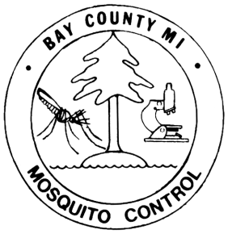
Bay County Mosquito Control
810 Livingston Street
Bay City, MI 48708
(989) 894-4555 Phone (989) 894-0526 Fax

2024

NO SPRAY REQUEST FORM
*Valid for Current Year Only*

Name _______________________________________ Phone

Address

City/State/Zip

Township_______________________ Section Number

Crossroads

E-Mail Address (optional)

Address of No Spray if different from above:

*If No Spray property has no street address, please provide parcel numbers OR a plat map showing parcel location and boundaries.

Do you wish to opt out of the following mosquito control services on your property?

- Adult Mosquito Control – Roadway treatment of adult mosquitoes after dusk using
truck-mounted ultra-low volume foggers………………………………………………………………….Yes, opt out
- Larval Control – Treatment of mosquito larvae in standing water. Products used include:
Bacillus thuringiensis israelensis (Bti), Bacillus sphaericus (Bs), Spinosad, Methoprene,
and larviciding oil………………………………………………………………………………………………...Yes, opt out
- Larval Control by Air – Each spring, flooded woodlots are treated by airplane with
Bacillus thuringiensis israelensis (Bti) to control larvae. If you have a wooded property,
do you wish to opt out of aerial treatment?.......................................................................Yes, opt out

This form must be completed and returned (mailed, emailed, or faxed) to our office by April 1st in order to honor your request for No Spray status, according to Bay County Resolution #93074 (see attached). Your cooperation is appreciated. If not returned by April 1st, your name and address will be removed from our list.

If opting out of Adult Mosquito Control, do you need yellow No Spray signs?.....................Yes No

Comments:

****REMINDER****
Signs must be properly maintained and visible to drivers throughout the entire season.

SIGNATURE & DATE

For office use only

Entered in Database Mapped Twp /Section # __________ Date Received __________

